**Tracking the Performance**

1. **Case 1**

Points: 500

Frame Aggregation: 1

Classes: 3

Batch Size: 32

Model Params: 30.5M

Learning Rate: 1e-4

Epochs: 100

Testing Accuracy: 88.81%

Testing AUC: 0.9791

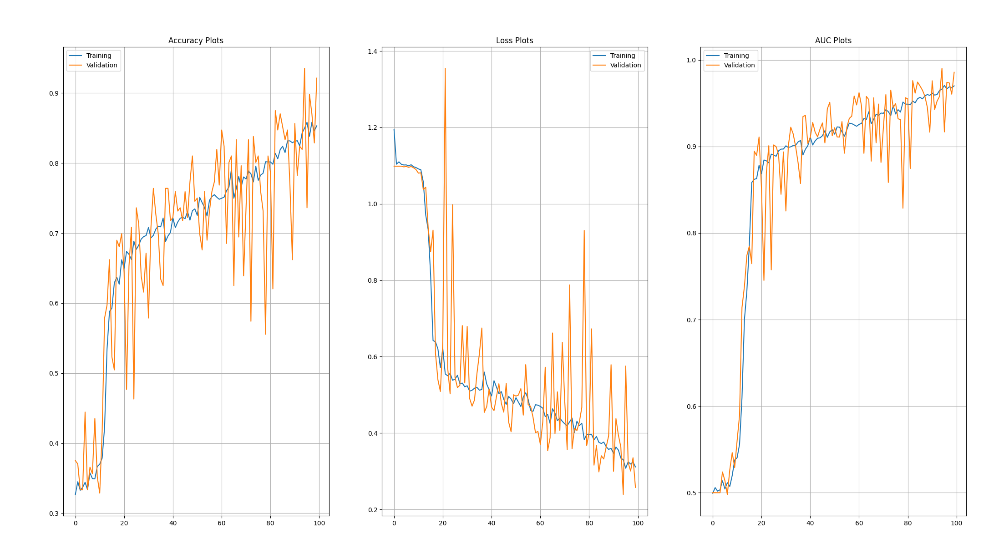

1. **Case 2**

Points: 500

Frame Aggregation: 4

Classes: 3

Batch Size: 32

Model Params: 30.5M

Learning Rate: 1e-4

Epochs: 100

Testing Accuracy: 96.39%

Testing AUC: 0.9975

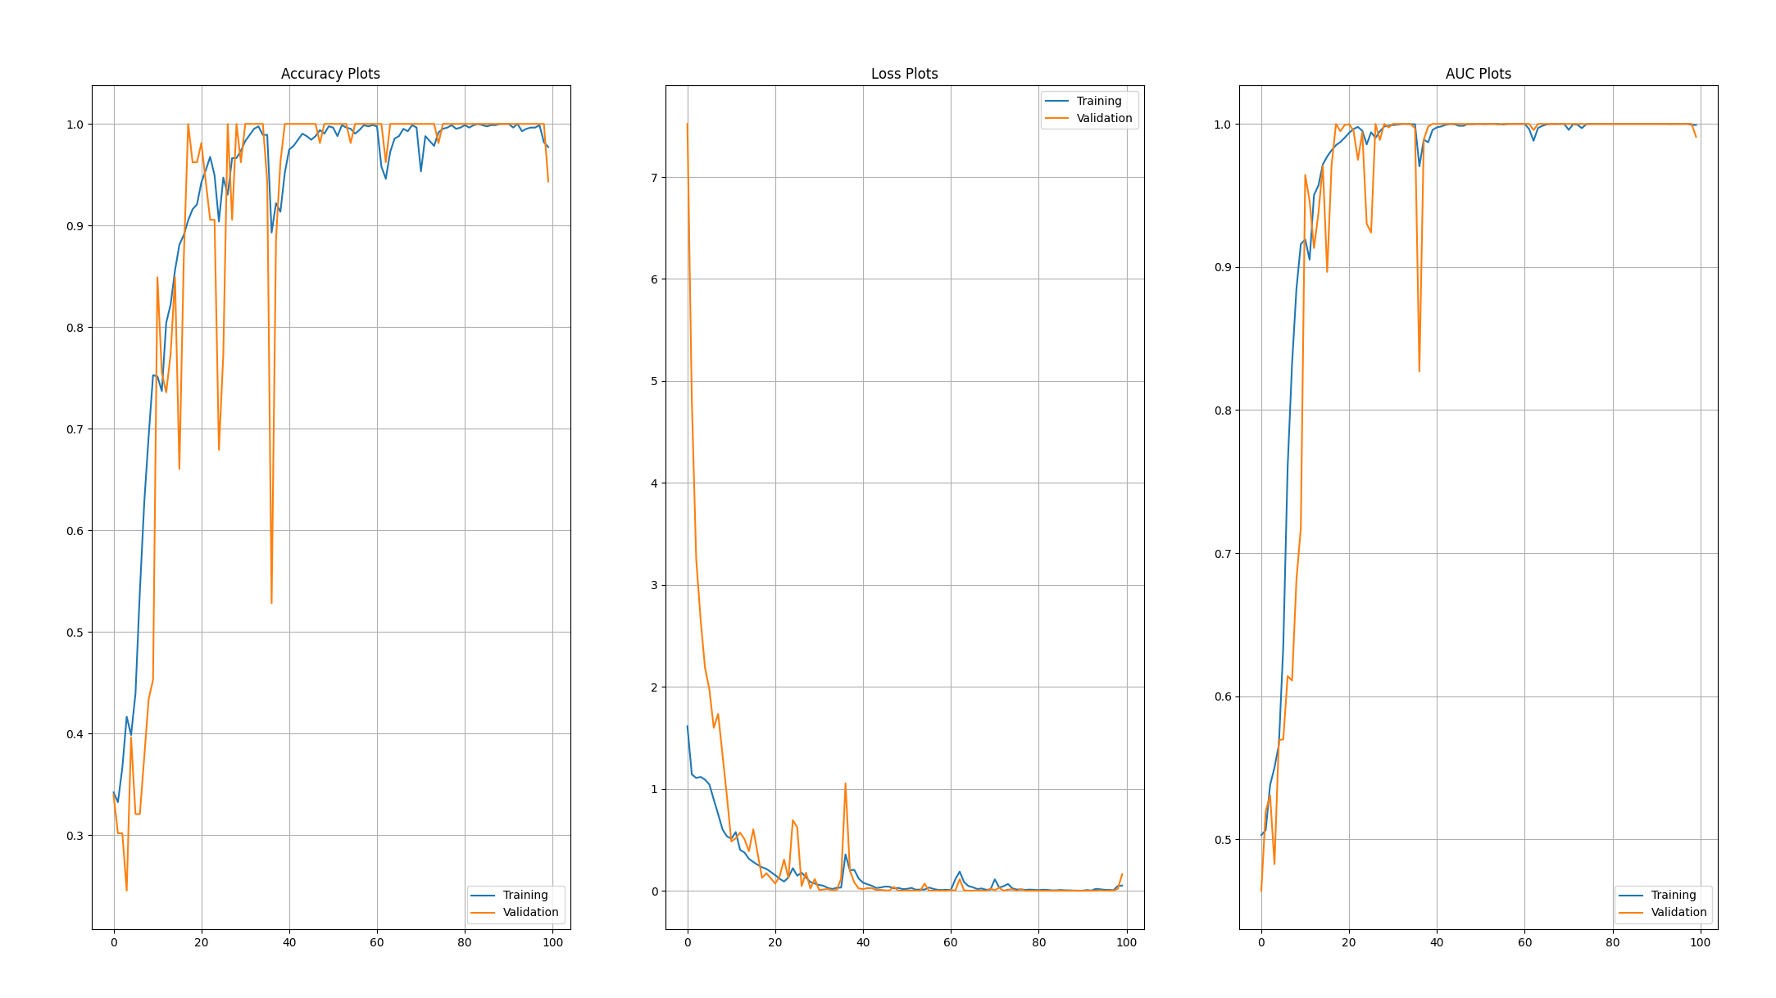

1. **Case 3**

Points: 500

Frame Aggregation 10

Classes: 3

Batch Size: 32

Model Params: 30.5M

Learning Rate: 1e-4

Epochs: 100

Testing Accuracy: 100% (How!?)

Testing AUC: 1 (Best Possible Result)

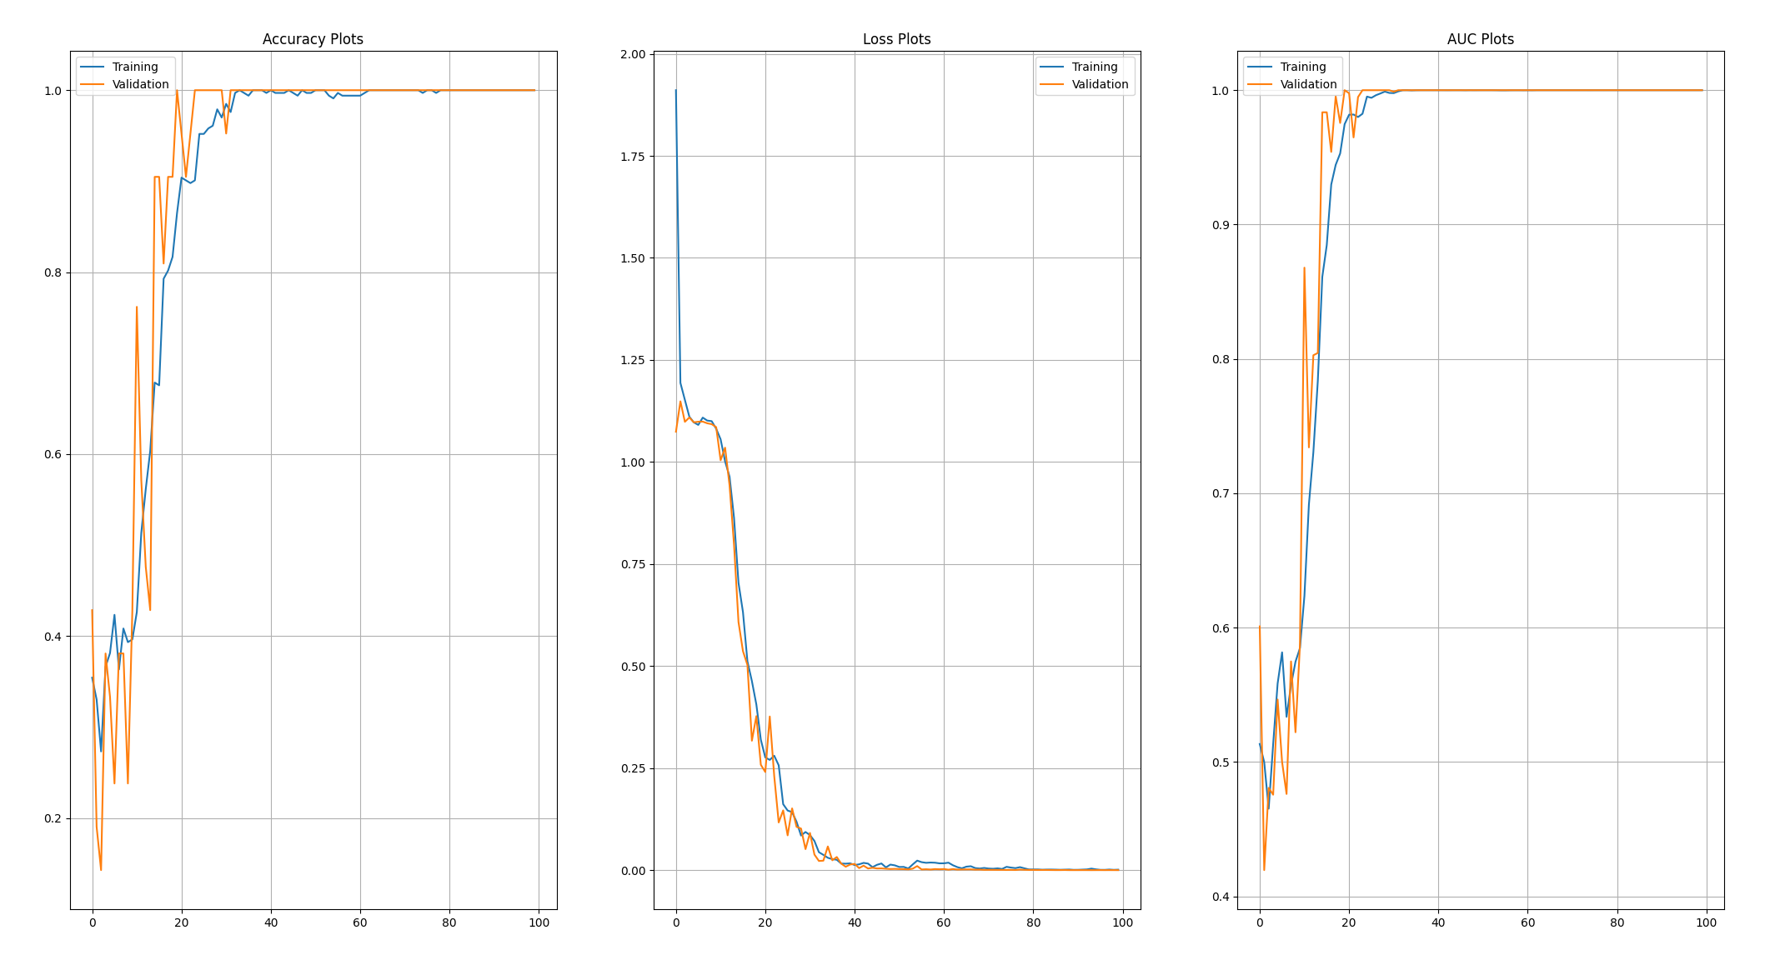

1. **Case 4**

Points: 300

Frame Aggregation 1

Classes: 3

Batch Size: 32

Model Params: 19.7M

Learning Rate: 1e-4

Epochs: 100

Testing Accuracy: 98.77%

Testing AUC: 0.9998

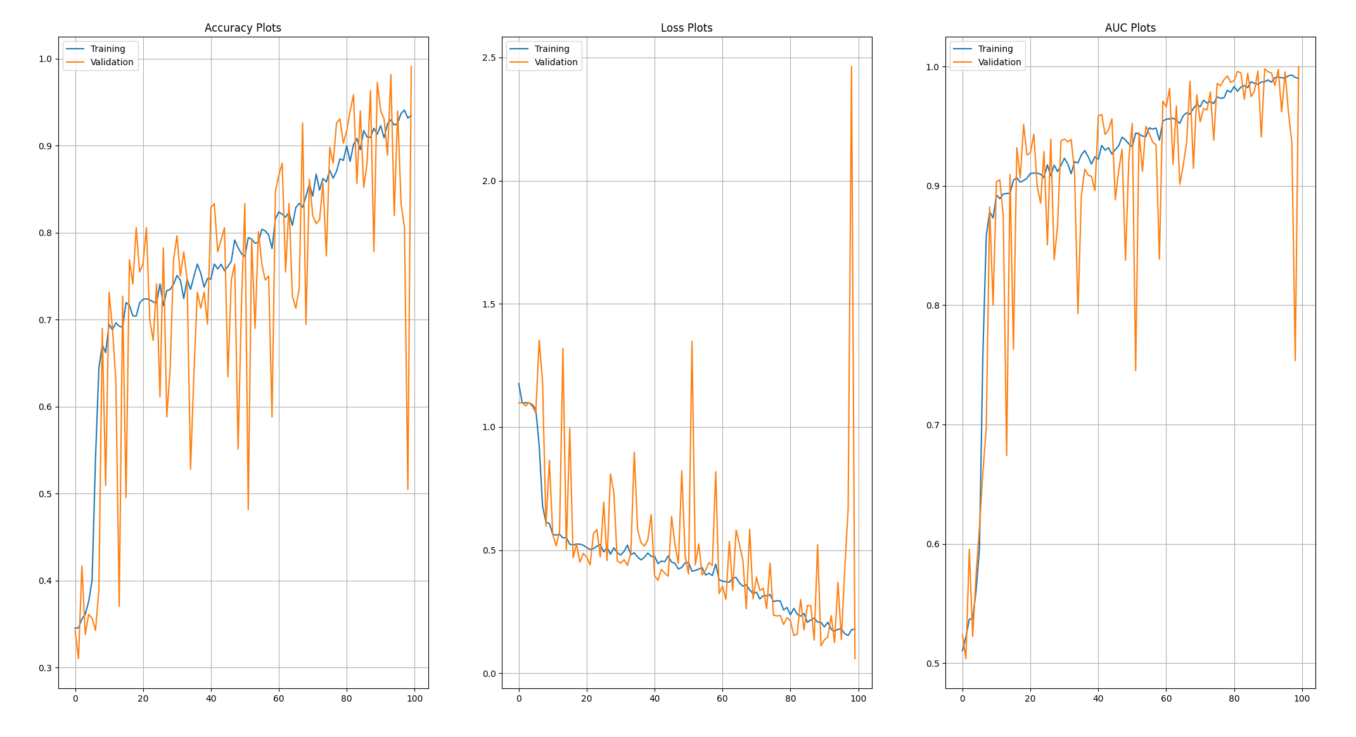

1. **Case 5**

Points: 300

Frame Aggregation 4

Classes: 3

Batch Size: 32

Model Params: 19.7M

Learning Rate: 1e-4

Epochs: 100

Testing Accuracy: 98.69%

Testing AUC: 0.9992

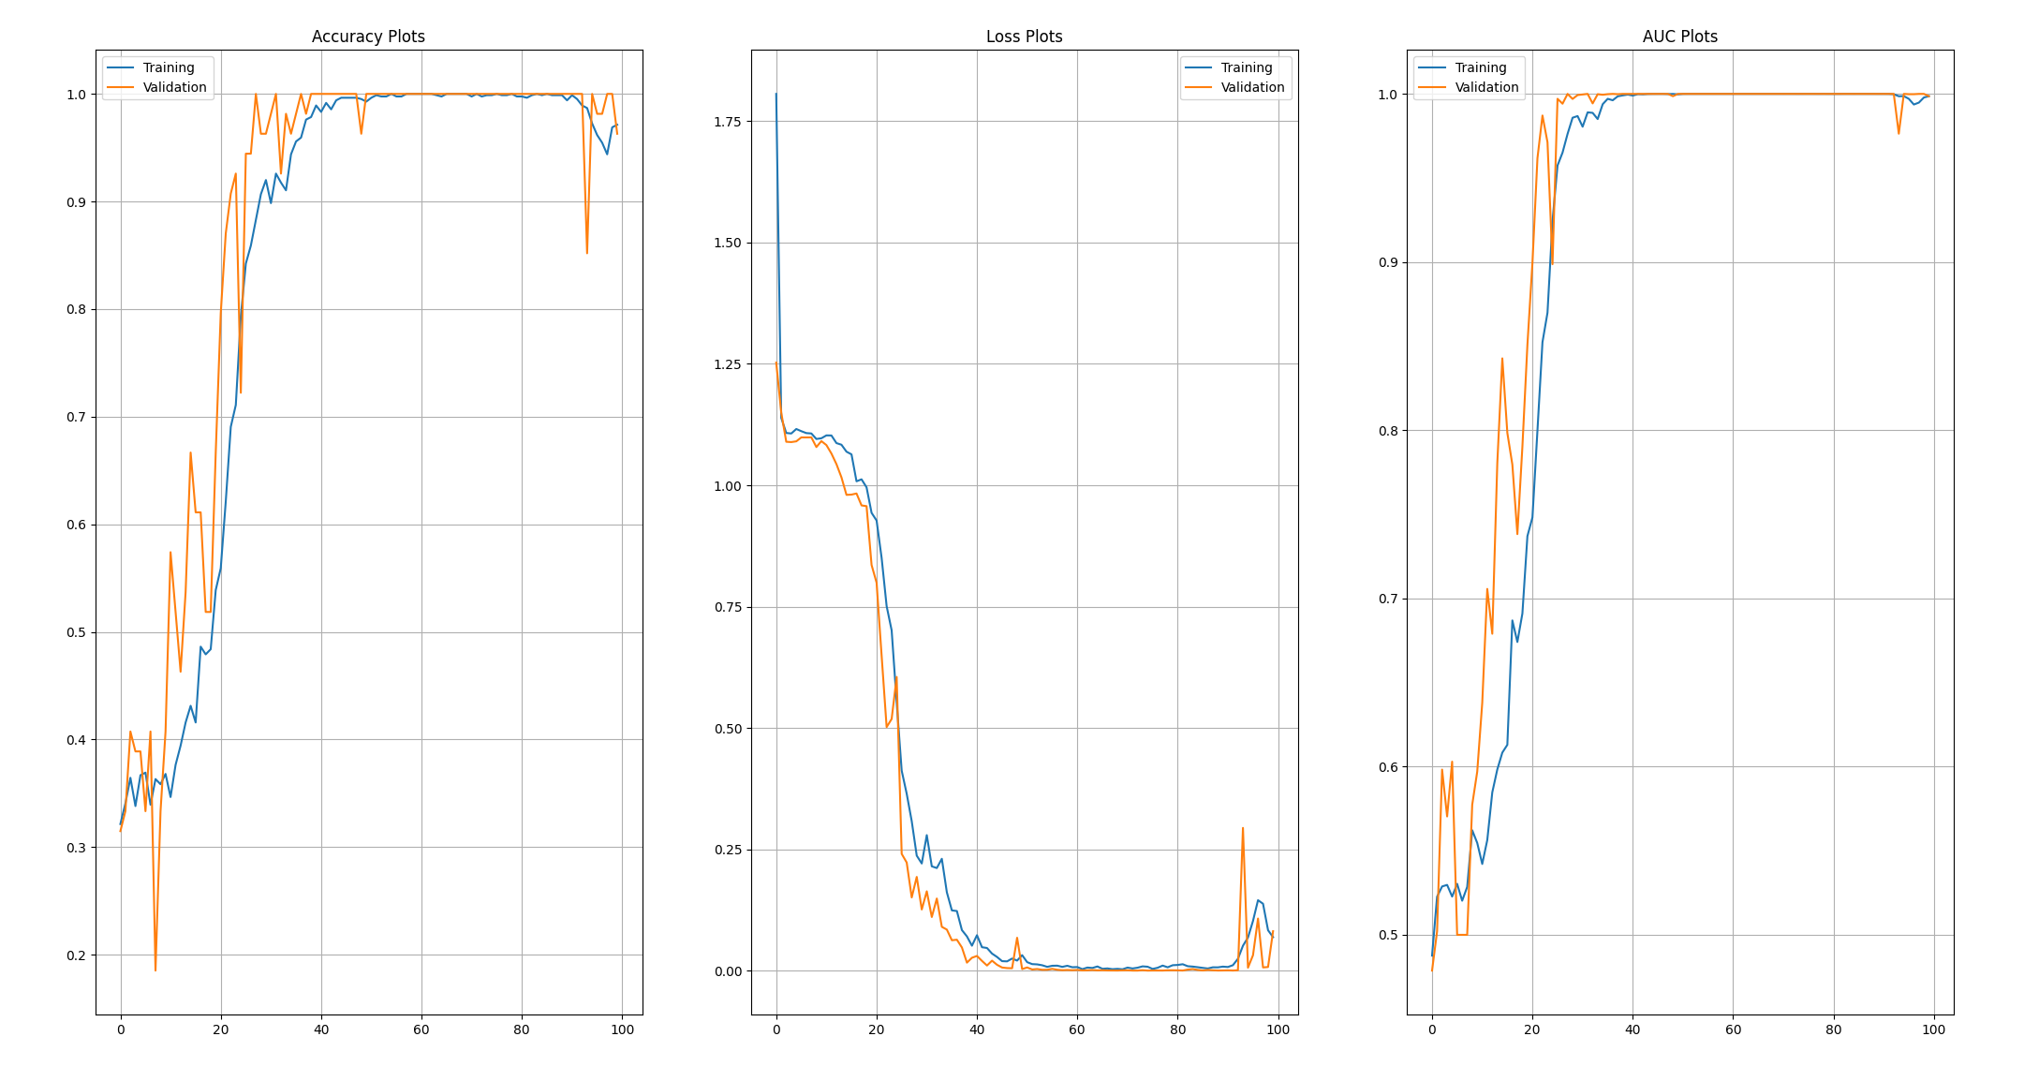

1. **Case 6**

Points: 300

Frame Aggregation 10

Classes: 3

Batch Size: 32

Model Params: 19.7M

Learning Rate: 1e-4

Epochs: 100

Testing Accuracy: 100% (How!?)

Testing AUC: 1 (Best Possible Result)

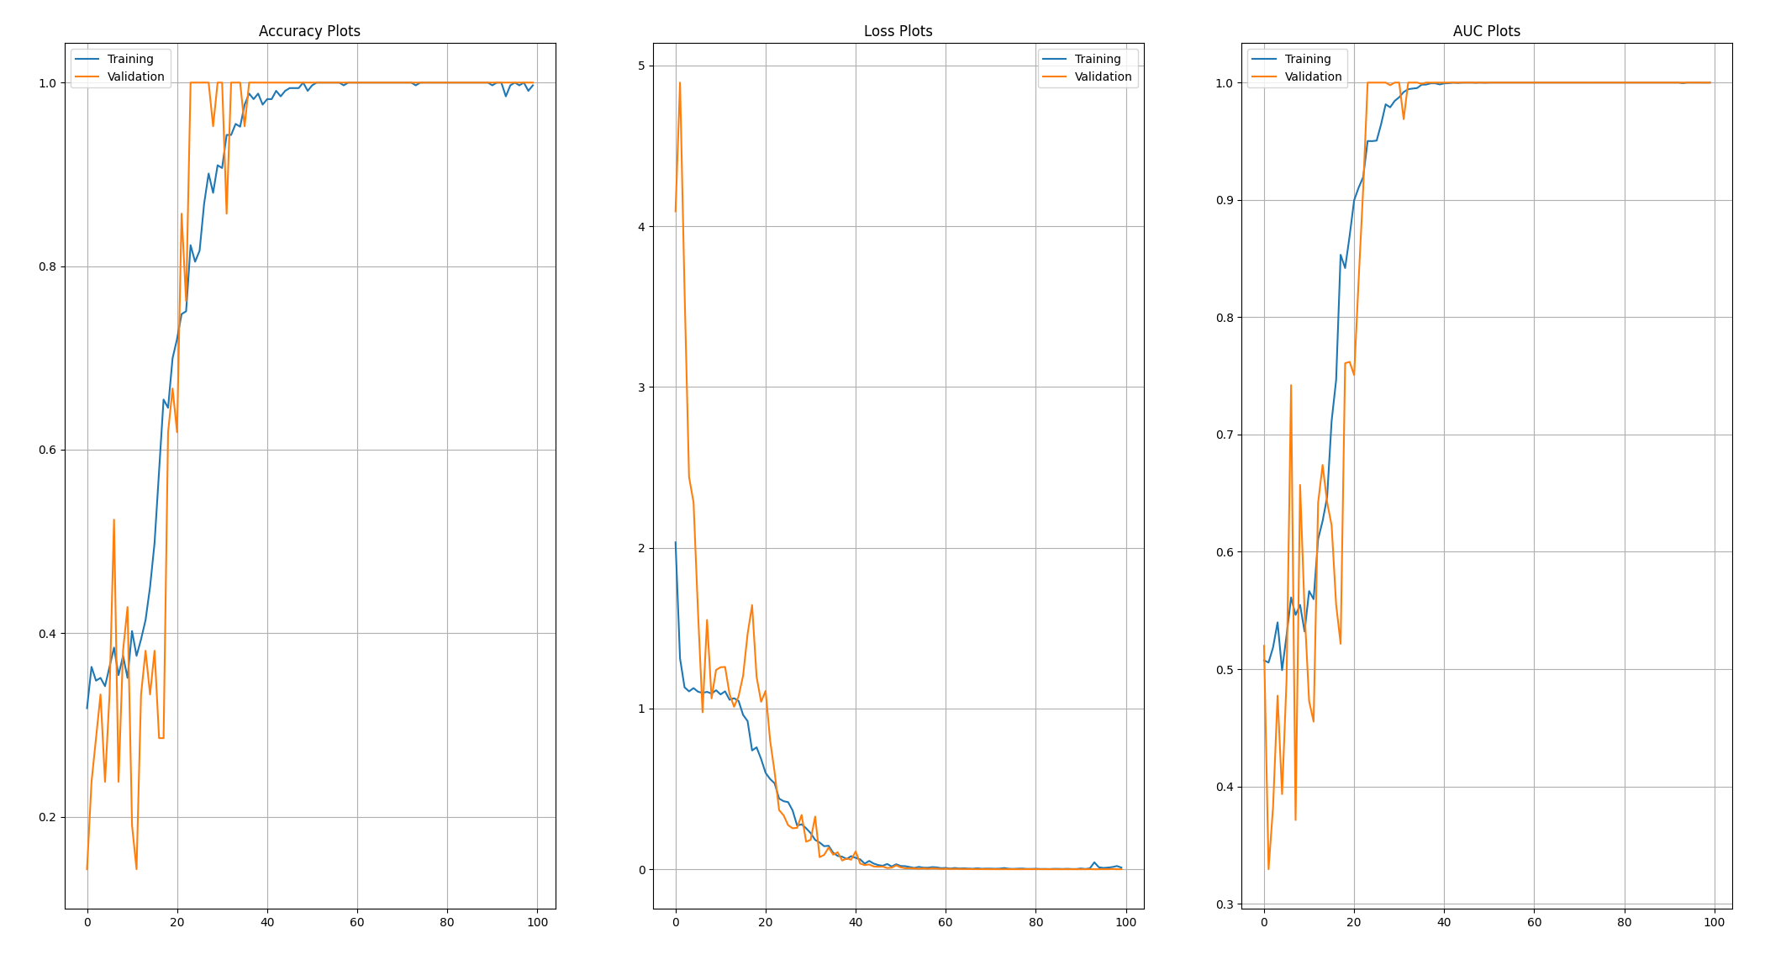

1. **Case 7**

Points: 300

Frame Aggregation 10

Classes: 2

Batch Size: 32

Model Params: 19.7M

Learning Rate: 1e-4

Epochs: 100

Testing Accuracy: 100% (How!?)

Testing AUC: 1 (Best Possible Result)

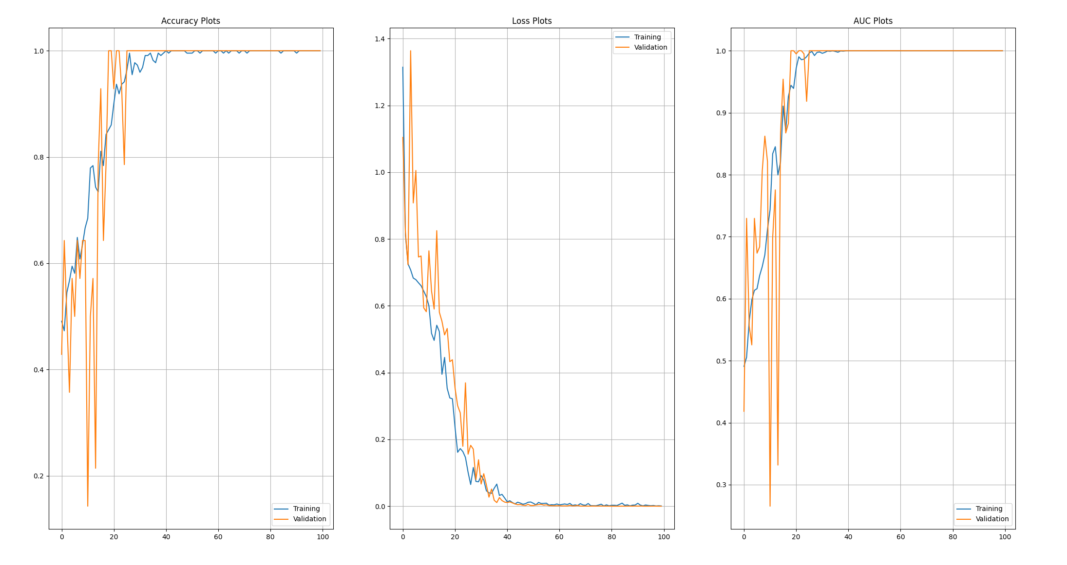

**More Observations**

1. The higher the frame aggregation, the lower the training samples and therefore leading to lower training time. However, the prediction time is nearly instantaneous.